**IPFS [InterPlanetary File System]**

**Definition and overview:-**

**IPFS is** a peer-to-peer (p2p) **distributed** storage network **for storing and accessing files, websites, applications, and data.**

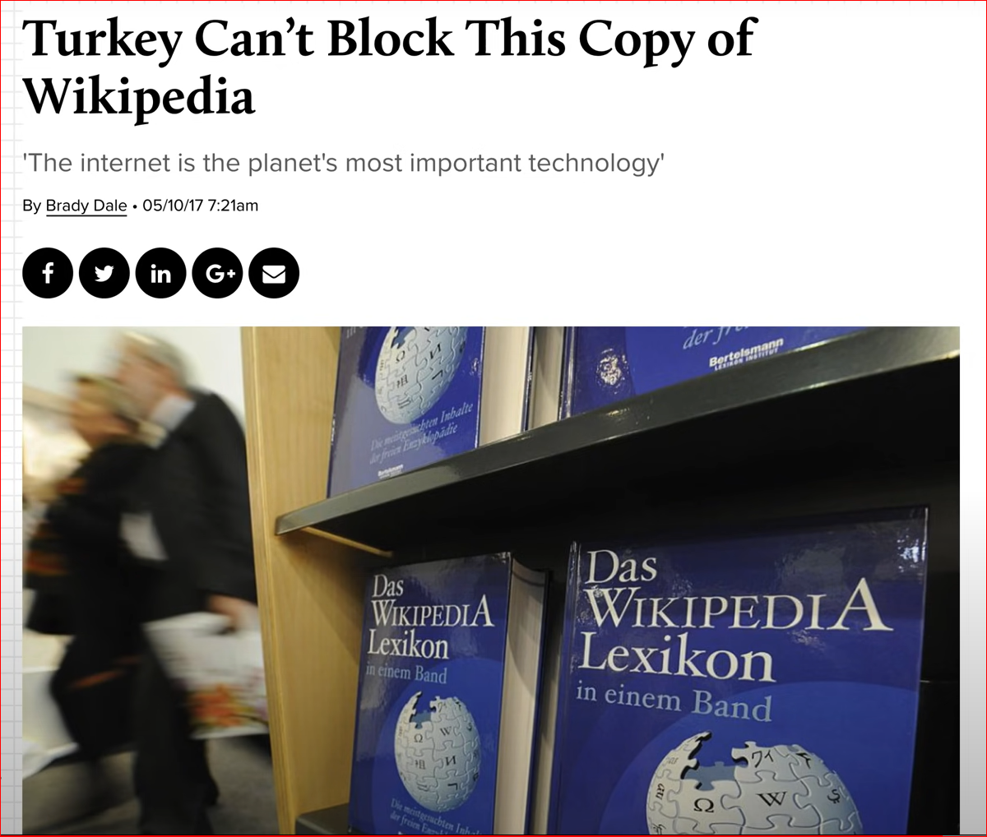



**Http vs IPFS Protocol:-**

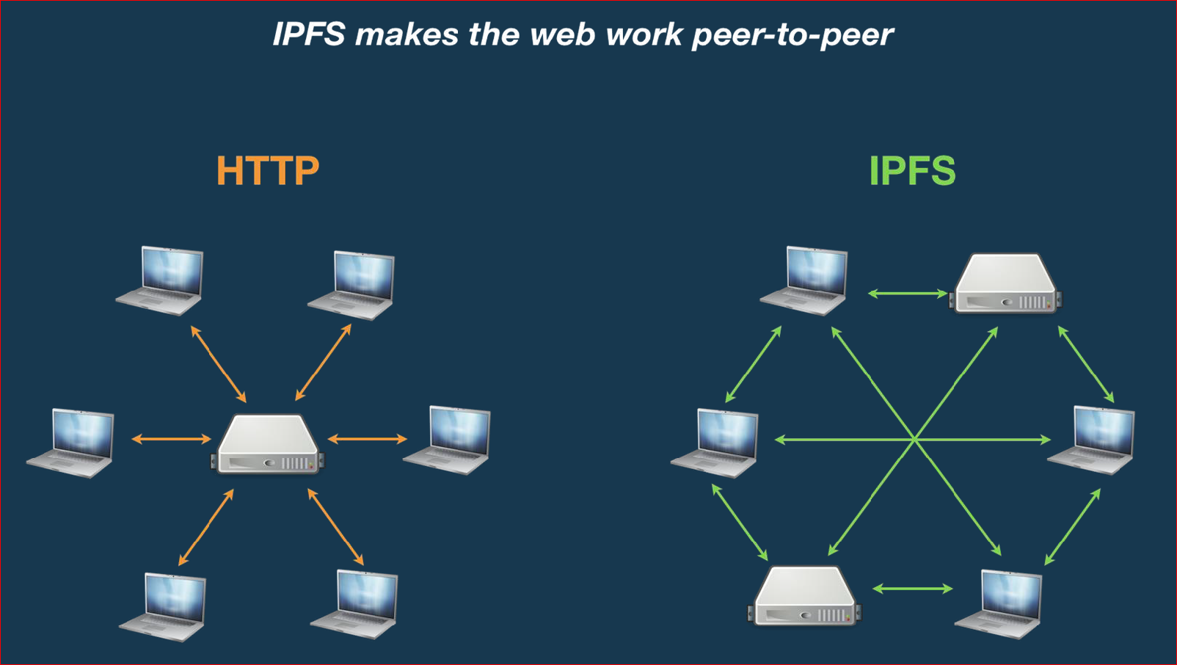

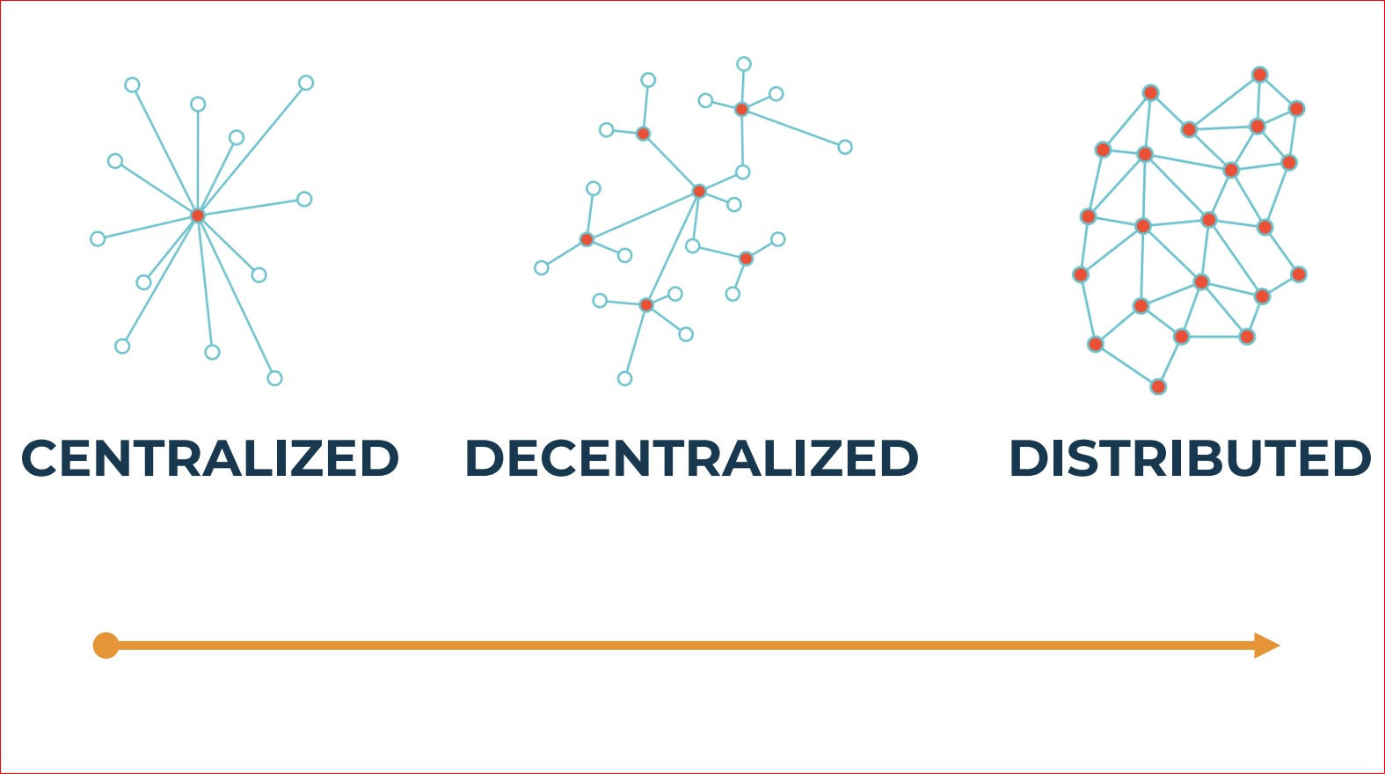

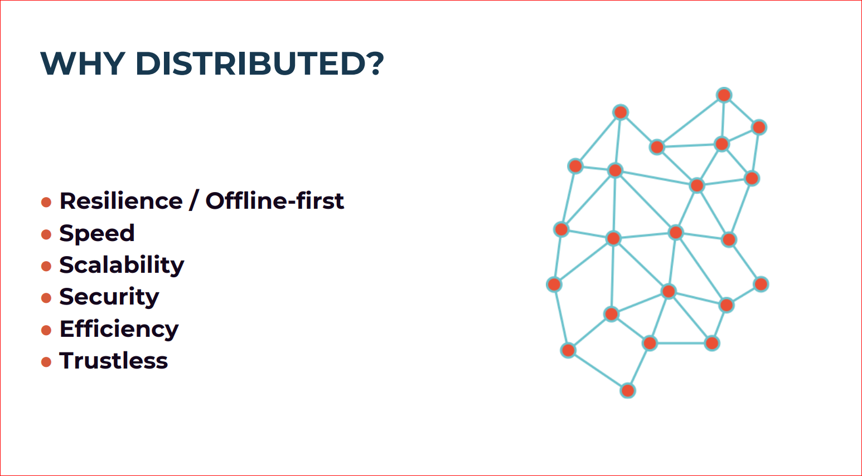

**Location based addressing vs Content Based Addressing:-**

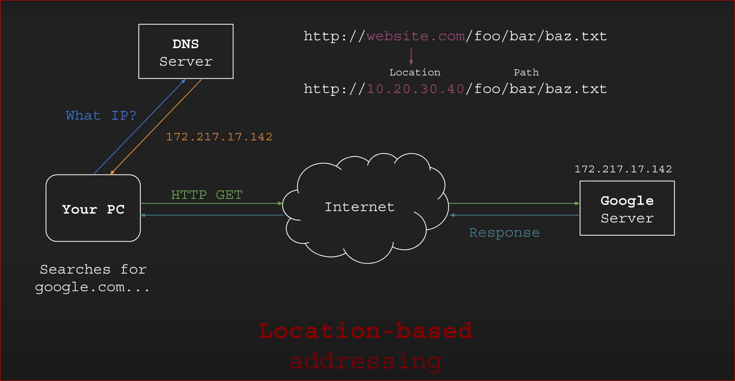

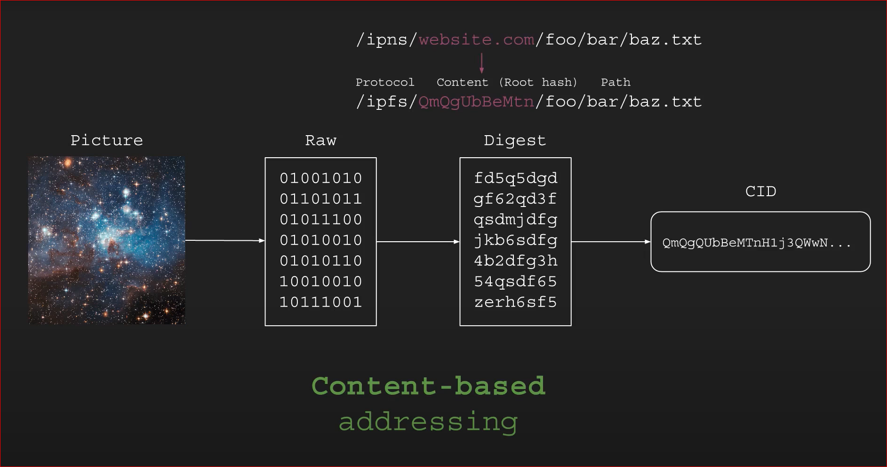

* Raw -> Digest => **SHA256 [Unique Identifier]**
* Digest -> CID => **Multi-Hash**

**IPFS Lifecycle:**

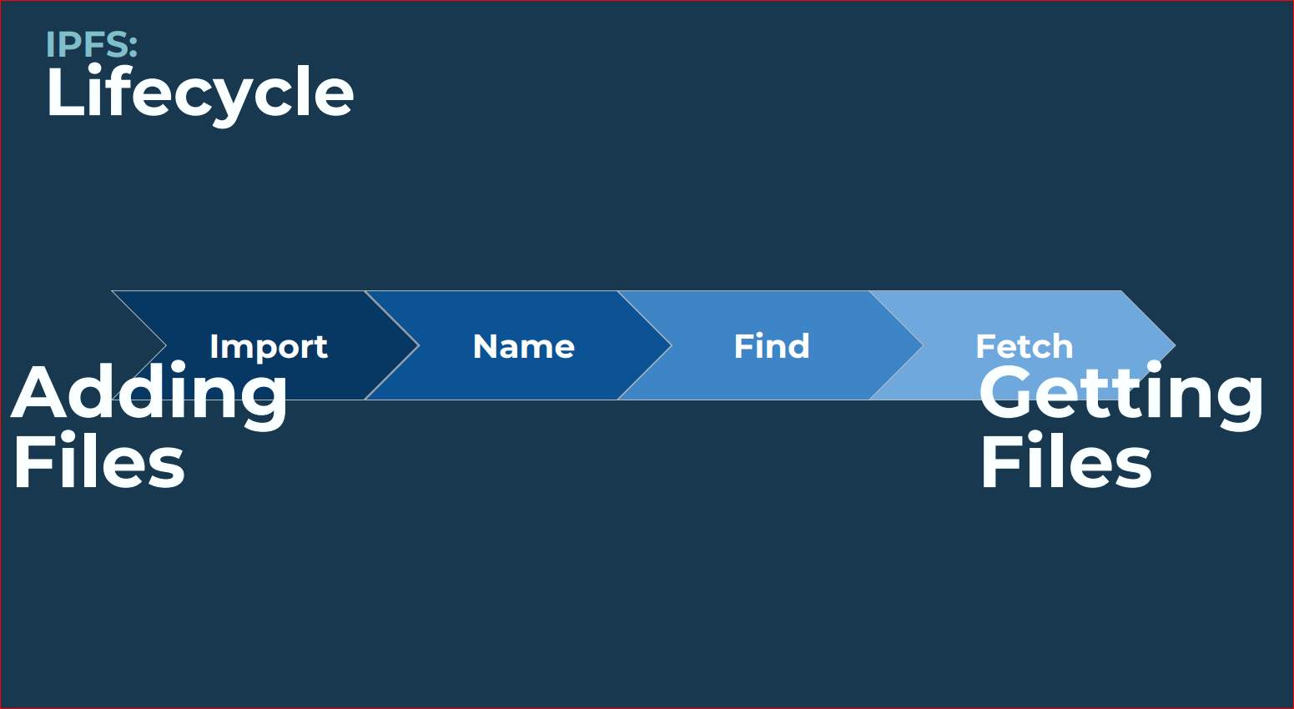

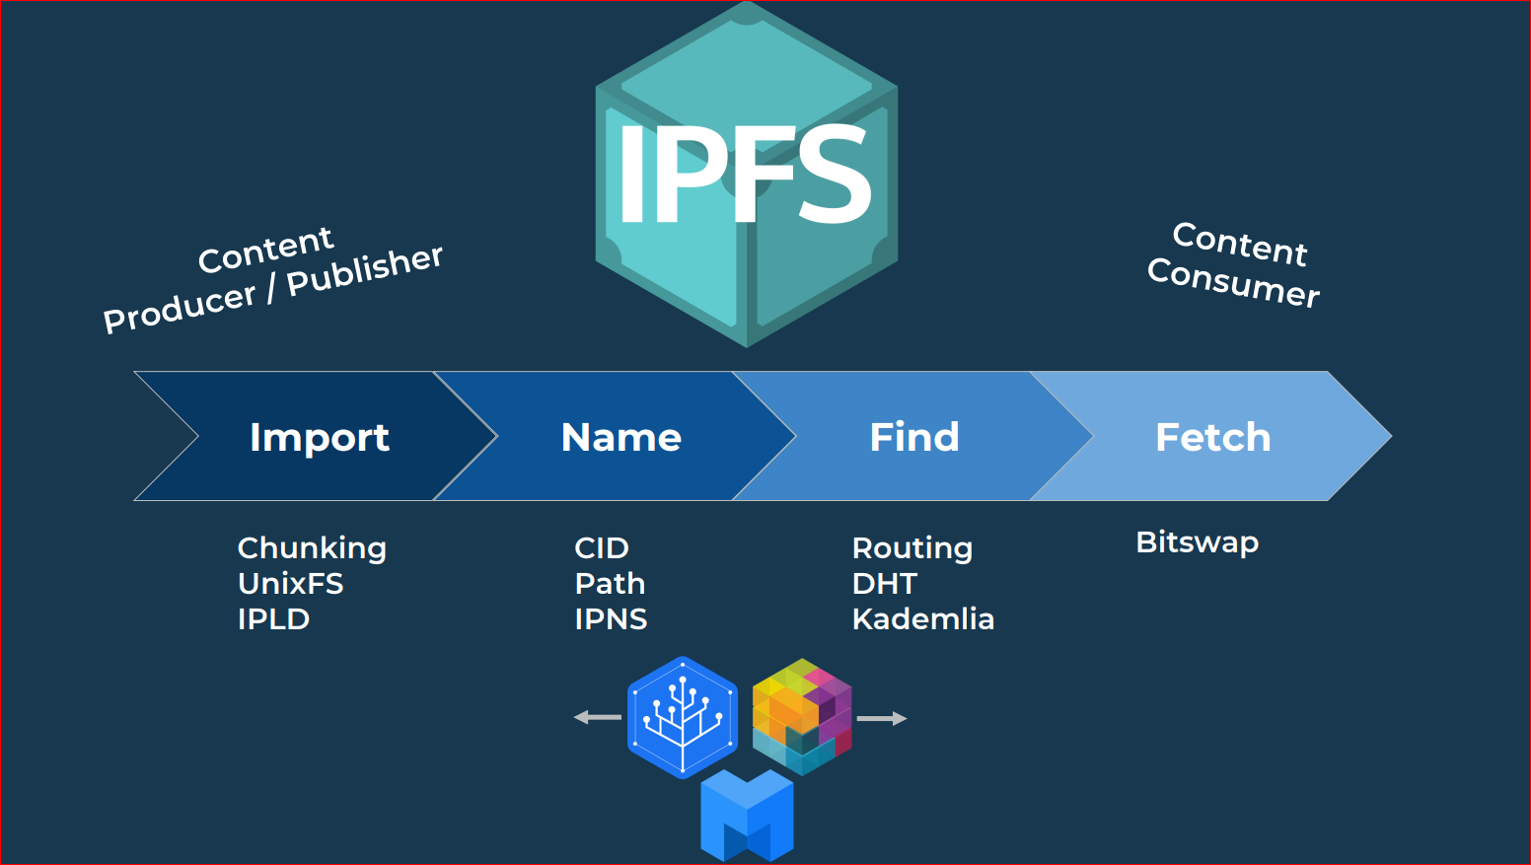

**IPLD [InterPlanetary Linked Data]:**

IPLD provides standards and formats to build Merkle-DAG data structures, like those that represent a filesystem.

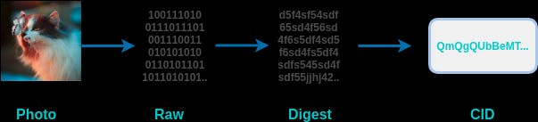

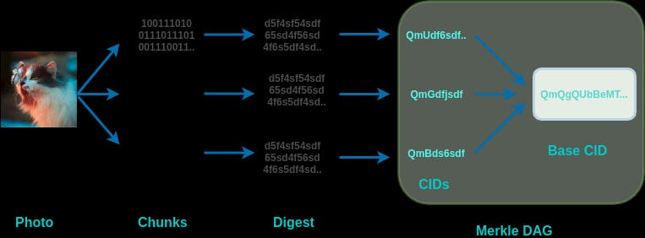

**Note**: If the files are bigger than **256 kB**, then they are broken down into smaller chunks, so that all the part are equal or smaller than **256 kb.** Each of these chunks is first converted into a digest and then into CIDs.

IPFS uses **IPLD** (**IPLD** uses [**Merkle DAG**](https://en.wikipedia.org/wiki/Merkle_tree?ref=hackernoon.com), or [directed acyclic graph](https://en.wikipedia.org/wiki/Directed_acyclic_graph?ref=hackernoon.com)) for managing all the chunks and linking it to the base CID.

**IPLD** (objects) consist of 2 components:

* Data — blob of unstructured binary data of size < 256 kB.
* Links — array of Link structures. These are links to other IPFS objects.

Every IPLD Link has 3 parts:

* Name — name of the Link
* Hash — hash of the linked IPFS object
* Size — the cumulative size of linked IPFS object, including following its links

**Command**: ipfs object get Qmd286K6pohQcTKYqnS1YhWrCiS4gz7Xi34sdwMe9USZ7u

{

"Links": [

{

"Name": "chunk-1",

"Hash": "QmZ5RgT3jJhRNMEgLSEsez9uz1oDnNeAysLLxRco8jz5Be",

"Size": 262158

},

{

"Name": "chunk-2",

"Hash": "QmUZvm5TertyZagJfoaw5E5DRvH6Ssu4Wsdfw69NHaNRTc",

"Size": 262158

},

{

"Name": "chunk-3",

"Hash": "QmTA3tDxTZn5DGaDshGTu9XHon3kcRt17dgyoomwbJkxvJ",

"Size": 262158

},

{

"Name": "chunk-4",

"Hash": "QmbsEhRqFwKAUoc6ivZyPa1vGUxFKBT4ciH79gVszPcFEG",

"Size": 69716

},

],

"Data": "\b\u0002\u0018Ơ�\u0001 ��\u0010 ��\u0010 ��\u0010 ��\u0010 ��\u0010 ��\u0010 ��\u0010 ��\u0010 ��\u0010 ��\u0010 ��\u0010 ��\u0010 ��\u0010 ��\u0010 Ơ\u0004"

}

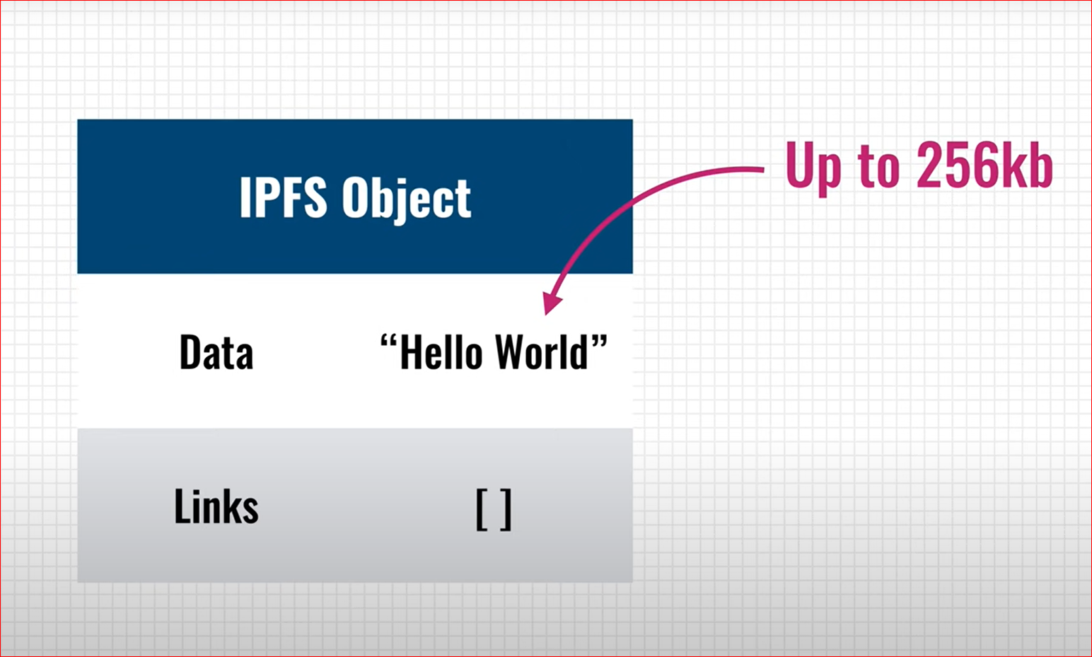

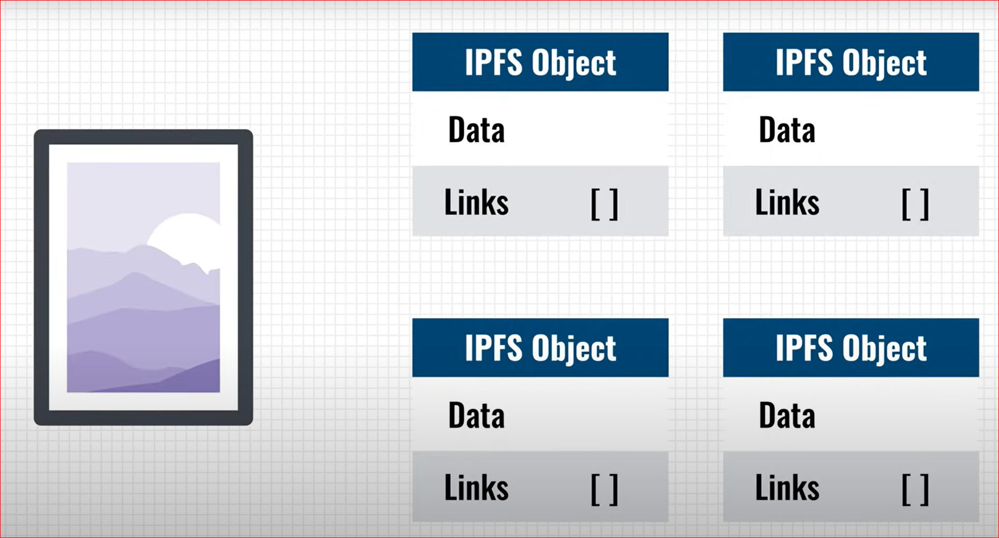

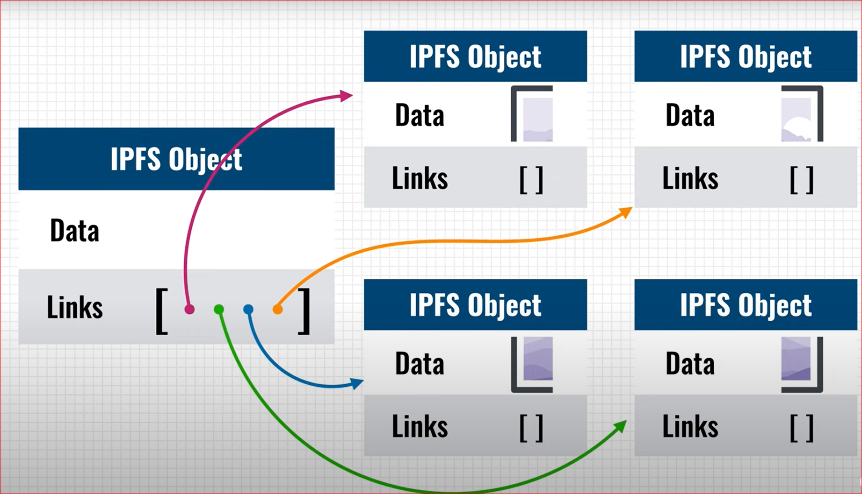

**Versioning:**

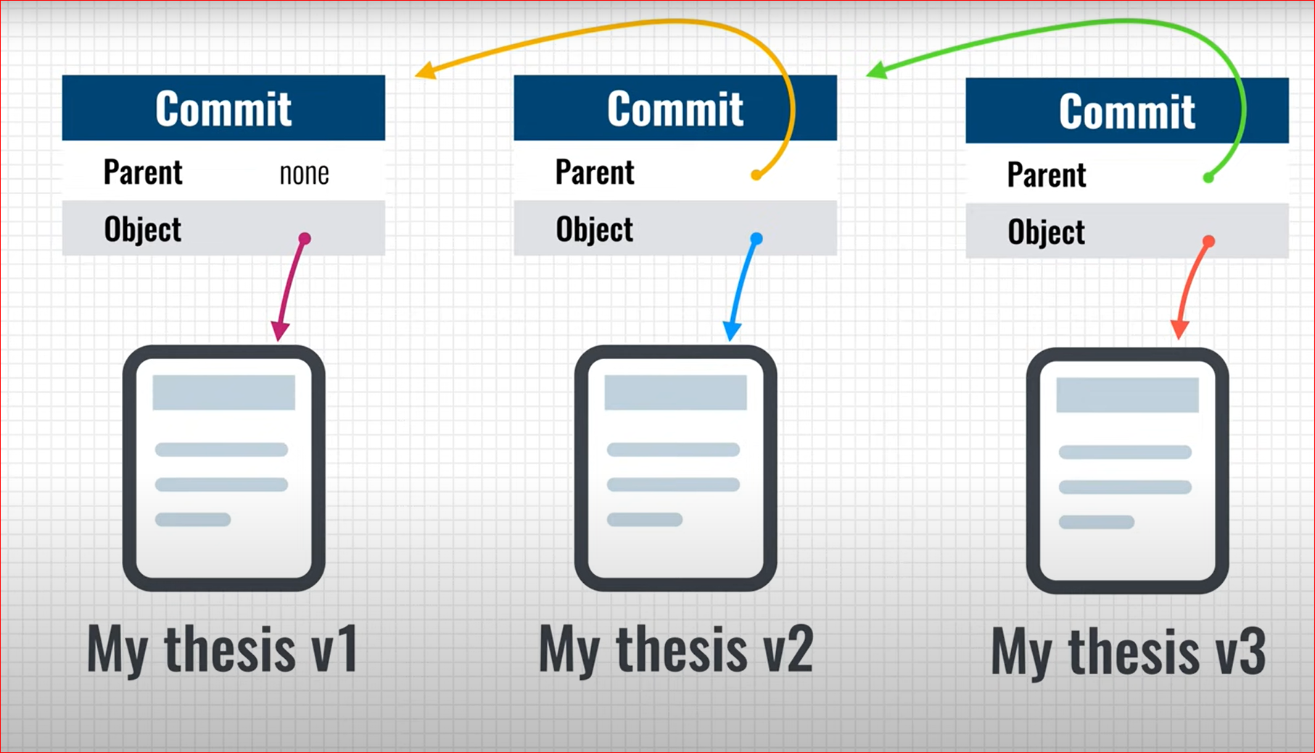

**Deduplication:**

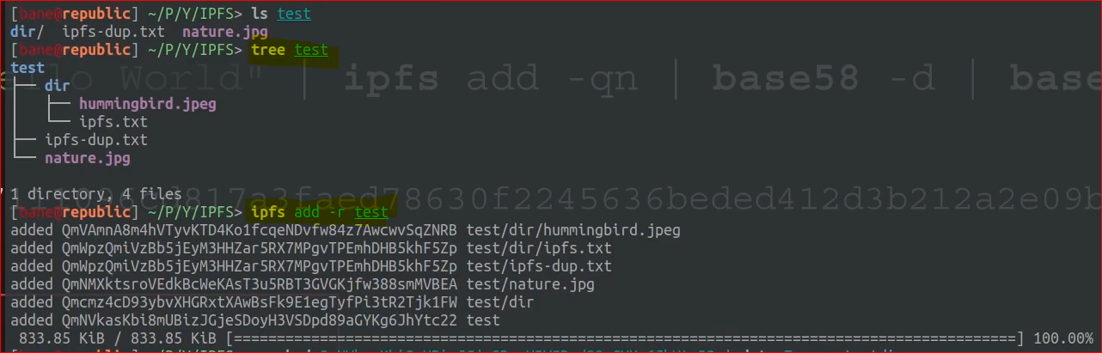

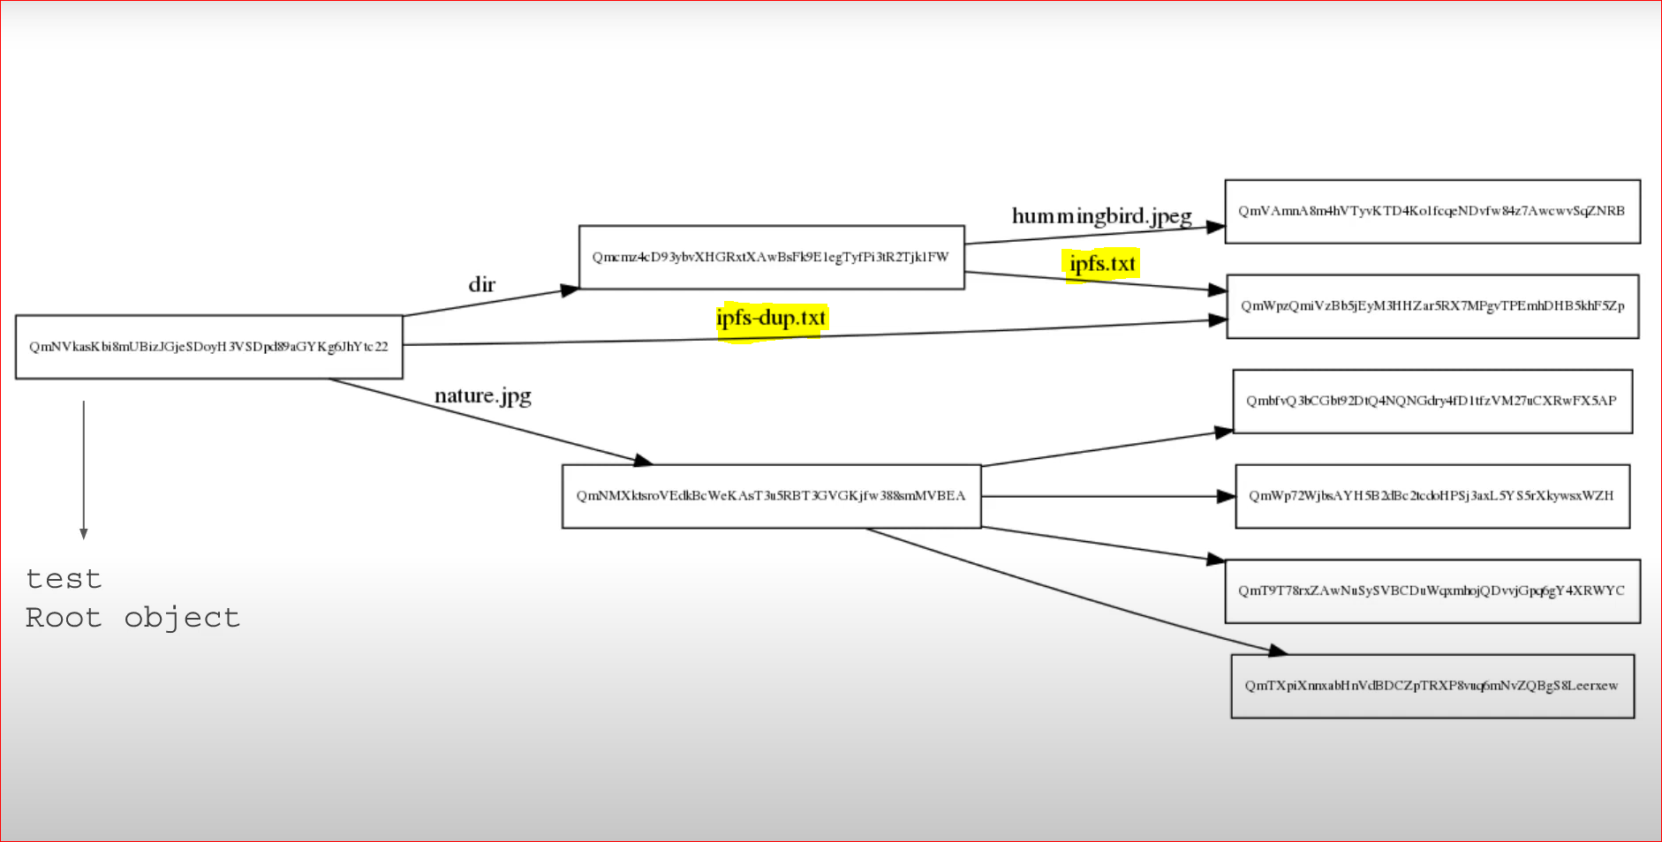

**IPNS [InterPlanetary Naming System]:**

To share IPFS address such as /ipfs/QmbezGequPwcsWo8UL4wDF6a8hYwM1hmbzYv2mnKkEWaUp with someone, we would need to give the person a **new link every time you update the content**.

**IPNS** solves this issue by creating an address([hash](https://docs.ipfs.io/concepts/hashing/) of a public key) that can be updated (mutable link).

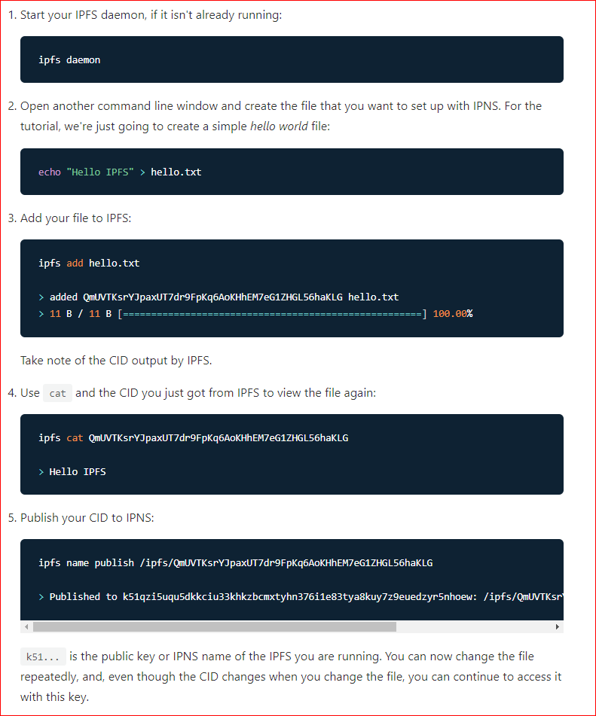

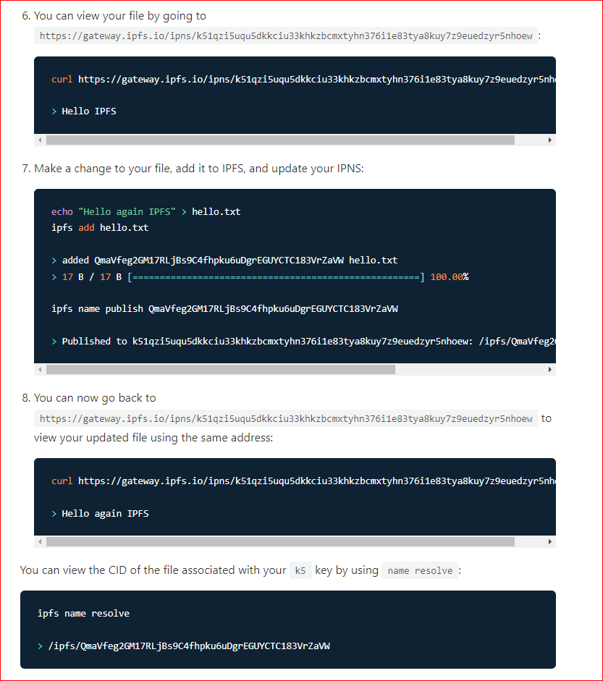

**DHT [Distributed Hash Table]:**

A Distributed Hash Table (DHT) provides a 2-column table (key-value store) maintained by multiple peers

The **DHT** in IPFS is used to provide:

* Content discovery (ContentID=PeerID)
* Peer routing (PeerID=/ip4/1.2.3.4/tcp/1234)

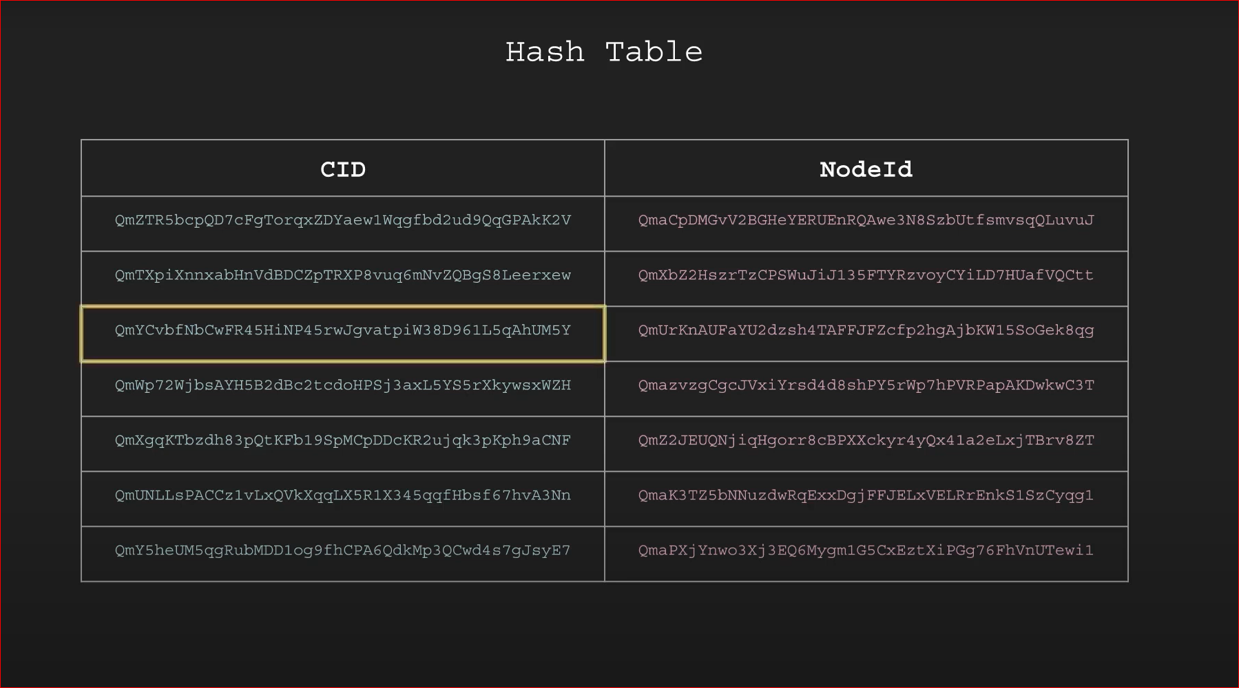

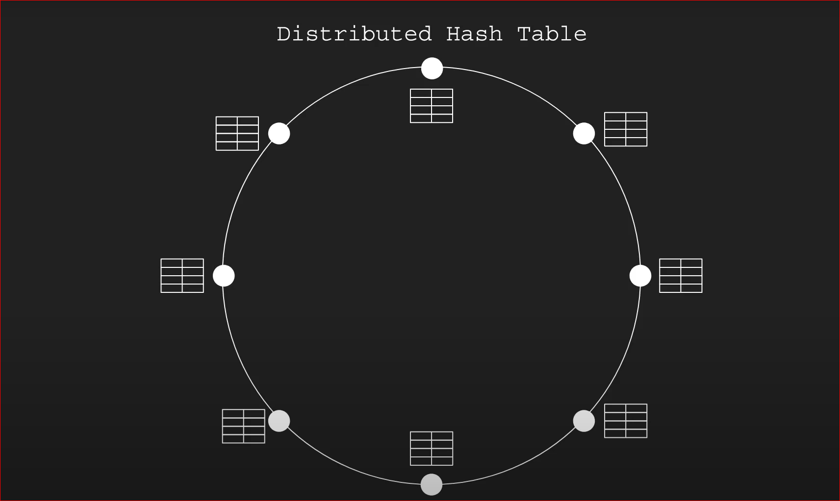

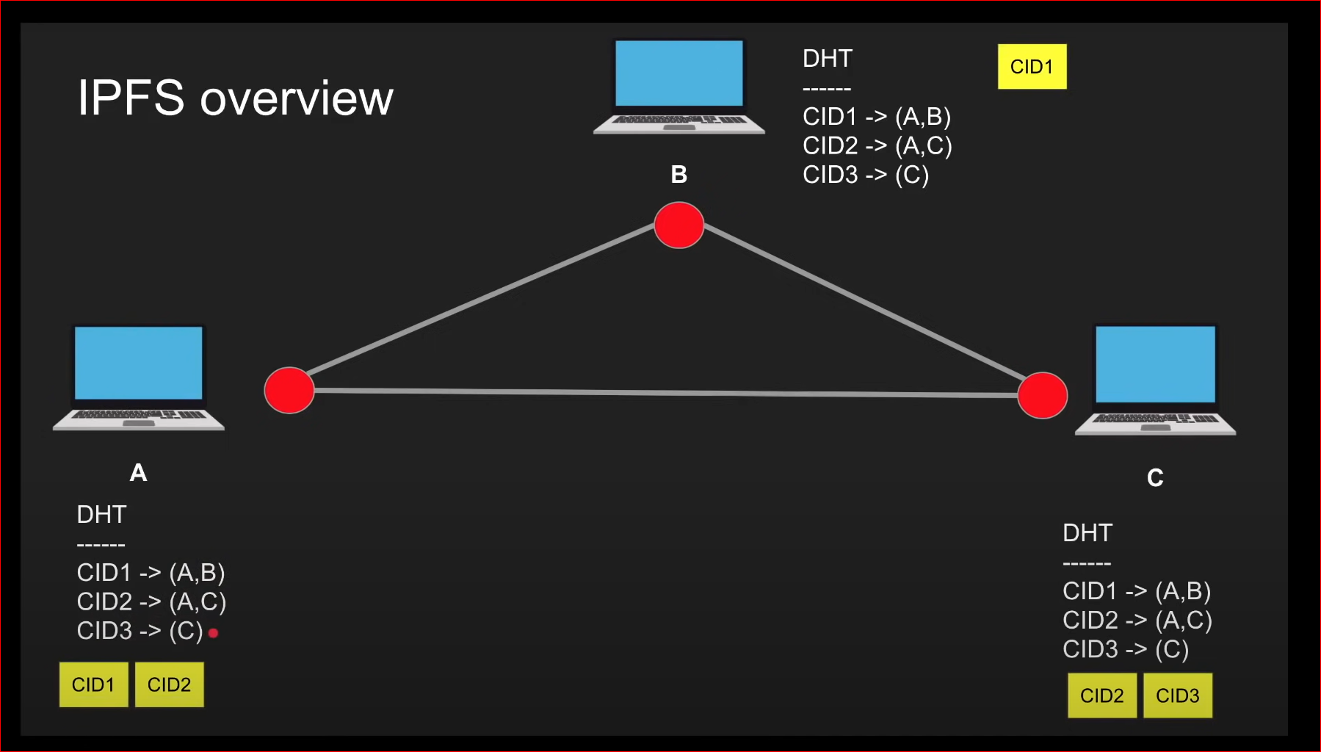

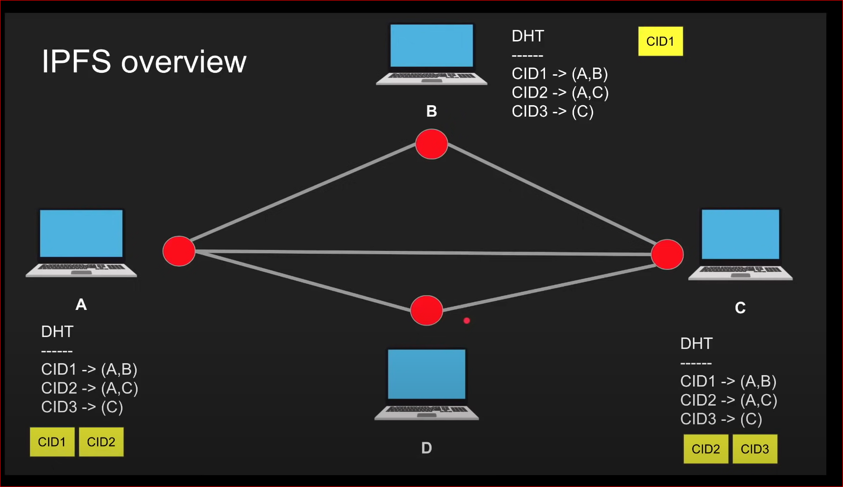

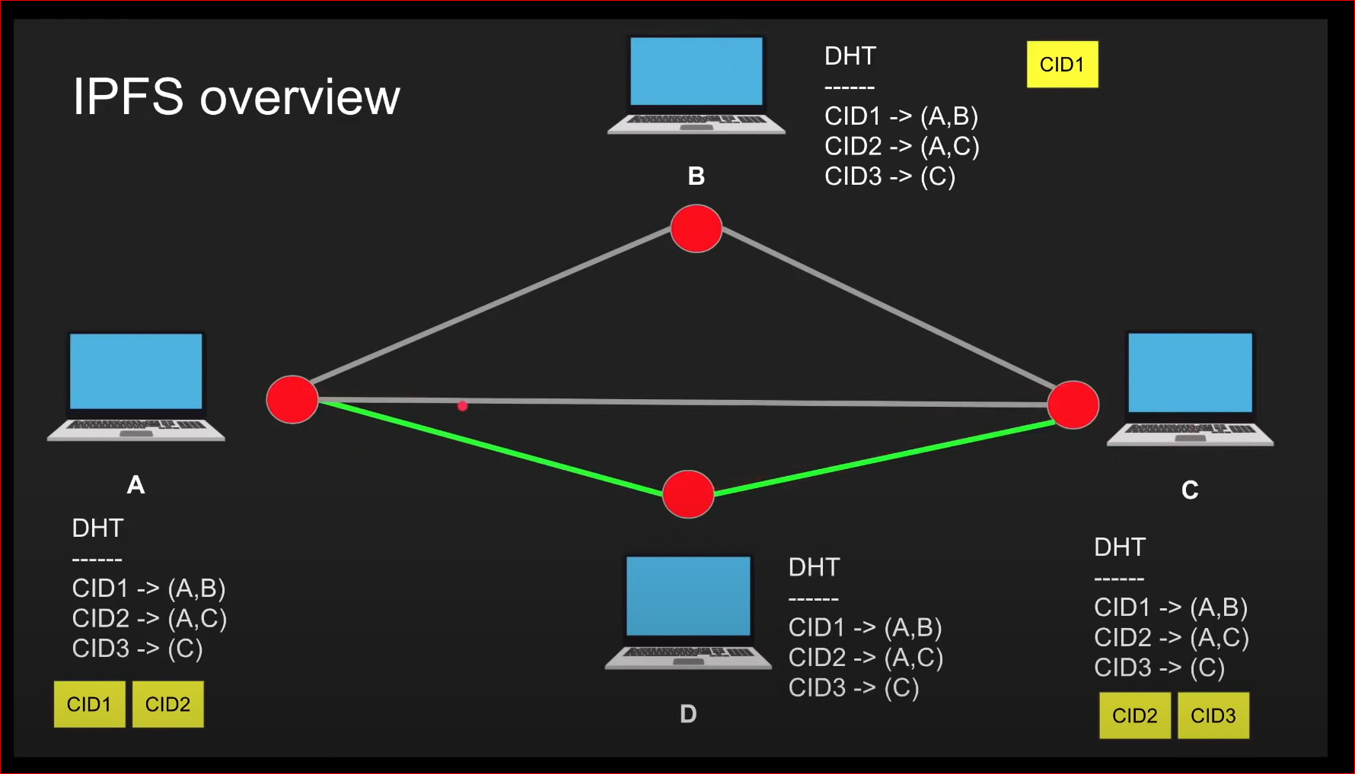

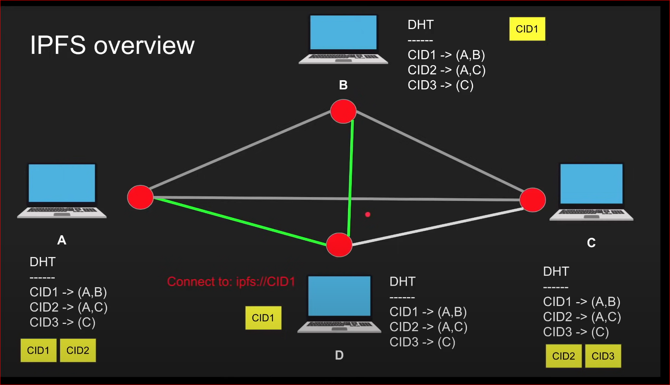

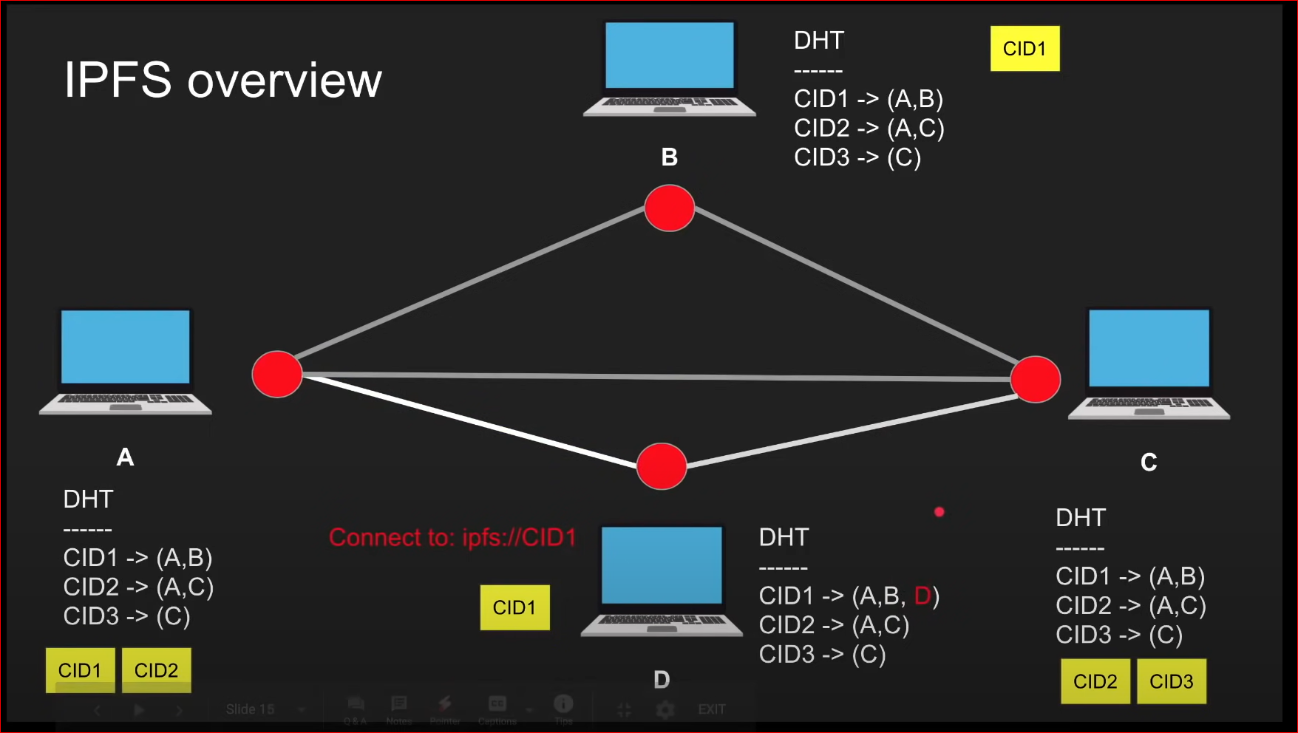

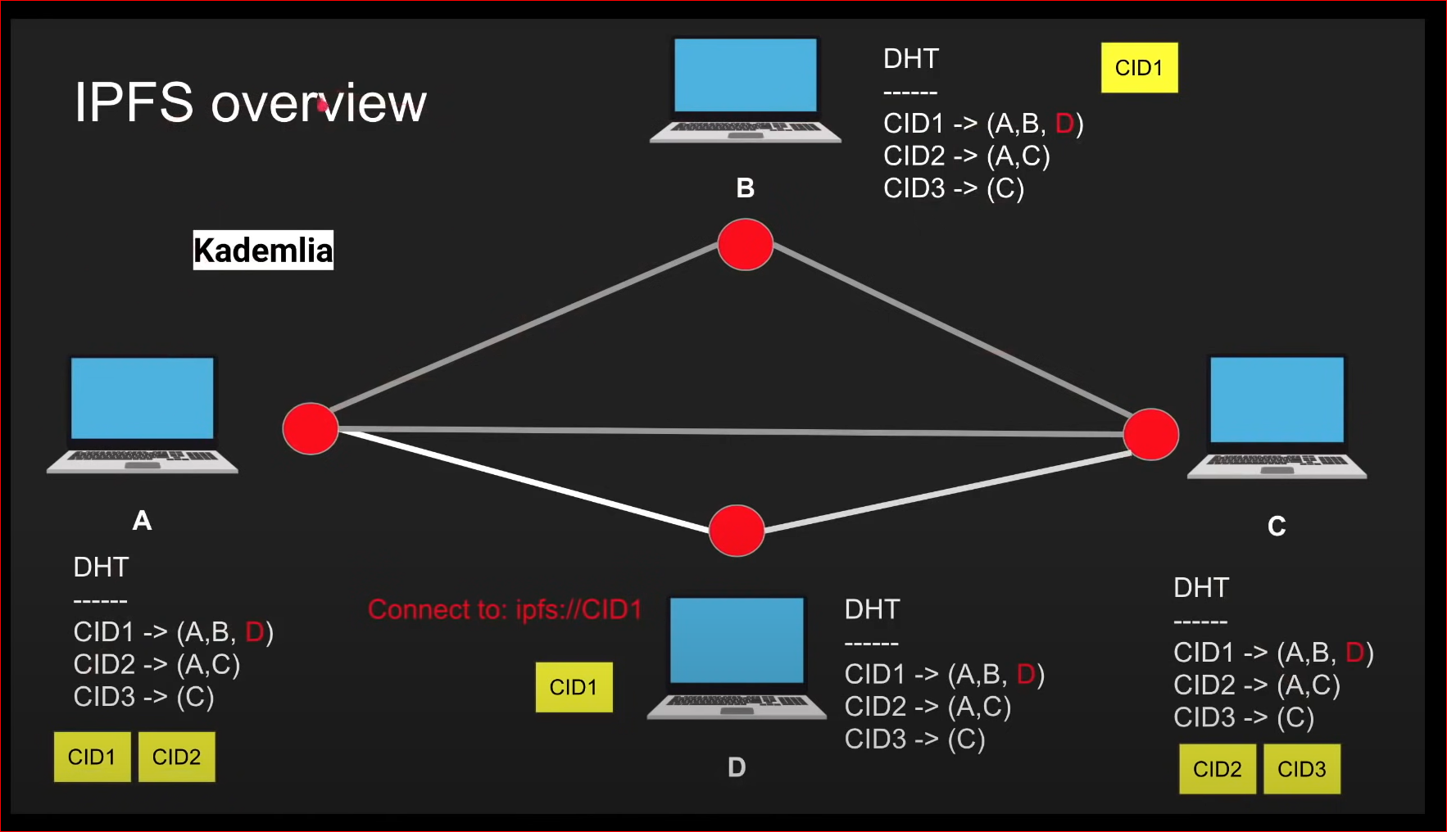

**Bitswap:**

**Bitswap** is a **core module of** IPFS for exchanging blocks of data. It directs the requesting and sending of blocks to and from other peers in the network.

**Bitswap** has two main jobs:

* Acquire blocks requested by the client from the network.
* Send blocks in its possession to other peers who want them

IPFS breaks up files into **chunks of data called *blocks***. These blocks are identified by a [content identifier (CID)](https://docs.ipfs.io/concepts/content-addressing). When nodes running the **Bitswap protocol** want to fetch a file, they send out want-lists to other peers. A want-list is a list of CIDs for blocks a peer wants to receive.

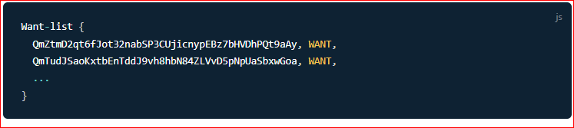

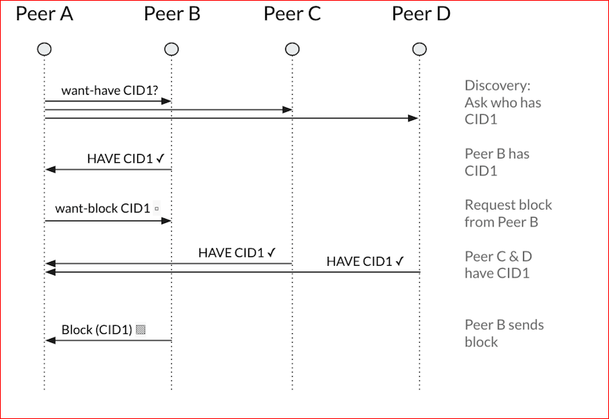

**Pining in IPFS:**

**Pinning** is a very important concept in IPFS.

Pinning is the mechanism that allows you to tell **IPFS to always keep a given object somewhere** — the **default being your local node (pinning)**.

IPFS has a fairly aggressive caching mechanism that will keep an object **local for a short time** after you perform any IPFS operation on it, but these objects may get **garbage-collected regularly**.

To prevent that garbage collection, **simply pin the CID** you care about, or add it to [**MFS**](https://docs.ipfs.io/concepts/file-systems/#mutable-file-system-mfs). Objects added through ipfs add are pinned **recursively by default**.

**Default behavior for IPFS pinning is to pin to local IPFS node** , but it's also possible to pin your files to a remote pinning service. These third-party services give you the opportunity to pin files not to your own local node, but to nodes that they operate.

**Problems in IPFS:**

* + Need pinning services to pin to other IPFS nodes
  + All IPFS nodes with pinned data might get shut down

